**DAILY ONLINE ACTIVITIES SUMMARY**

|  |  |  |  |  |  |  |  |  |
| --- | --- | --- | --- | --- | --- | --- | --- | --- |
| **Date:** | **23/07/2020** | | | | | **Name:** | **NAIPUNYA VINOD NAIK** | |
| **Sem & Sec** | **IV SEM & A SECTION** | | | | | **USN:** | **4AL18CS050** | |
| **Online Test Summary** | | | | | | | | |
| **Subject** | | **NO INTERNALS CONDUCTED** | | | | | | |
| **Max. Marks** | | **30** | | **Score** | | | **----------------** | |
| **Certification Course Summary** | | | | | | | | |
| **Course** | 1. **ONLINE WORKSHOP OF PYTHONIC CODING RATHER THAN PYTHON CODING – LOGICAL PERSPECTIVE** 2. **ETHICAL HACKING MIT KALI LINUX** | | | | | | | |
| **Certificate Provider** | | | **1) AIET**  **2) UDEMY** | | **Duration** | | | **1)2.5 HRS**  **2) 4 HRS** |
| **Coding Challenges** | | | | | | | | |
| **Problem Statement: HACKERRANK OPERATORS PROBLEM** | | | | | | | | |
| **Status: EXECUTED** | | | | | | | | |
| **Uploaded the report in Github** | | | | | **YES** | | | |
| **If yes Repository name** | | | | | <https://github.com/naipunya-naik/Online-Coding-platform-coding/blob/master/OPERATORS_23-07-2020.cpp> | | | |
| **Uploaded the report in slack** | | | | | **YES** | | | |

Online Test Details: (Attach the snapshot and briefly write the report for the same).

NO INTERNALS CONDUCTED

Certification Course Details: (Attach the snapshot and briefly write the report for the same).

1. **ONLINE WORKSHOP OF PYTHONIC CODING RATHER THAN PYTHON CODING – LOGICAL PERSPECTIVE**
2. TODAY WE ATTENDED THE THIRD DAY OF 4-DAY PYTHON WORKSHOP.
3. CONDUCTED BY:- DR S.MOHIDEEN BADHUSHA, PROFESSOR, CSE DEPT, AIET.
4. WE HAD 2 SESSIONS ON DAY 3.
5. I EXECUTED WORKED OUT EXAMPLES AND EXERCISES ON GOOGLE COLAB AND POSTED IT ON MY GITHUB REPOSITORY.

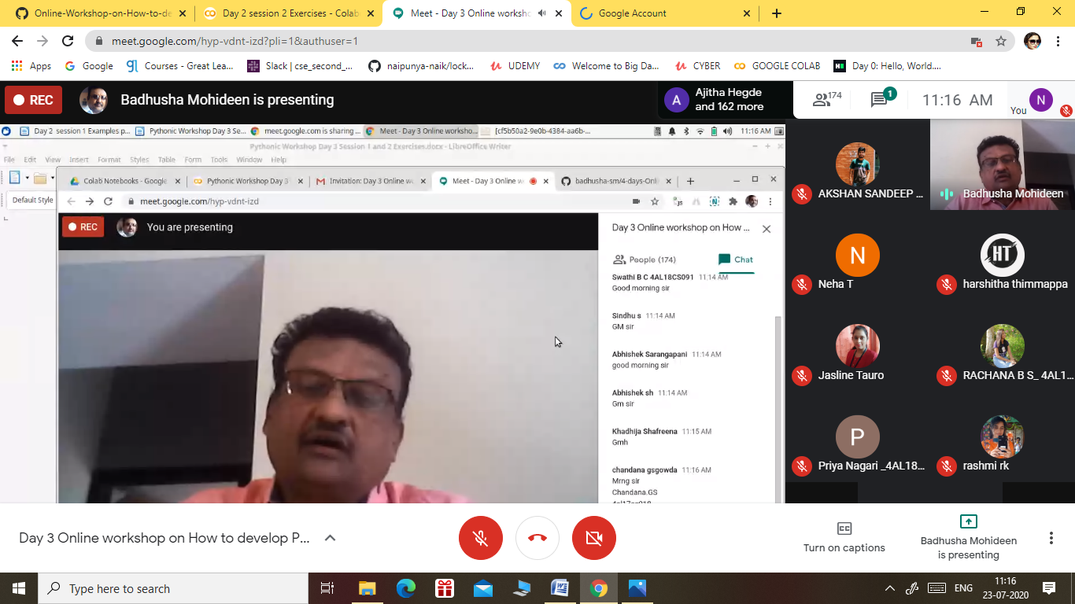

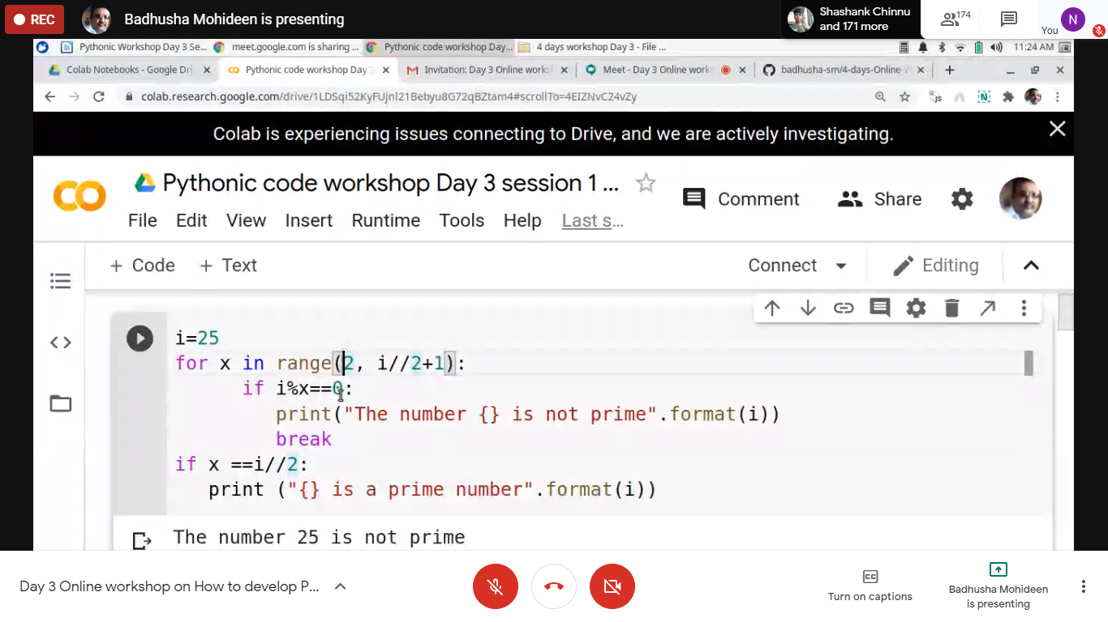

2)CERTIFICATION COURSE NAME:- ETHICAL HACKING MIT KALI LINUX

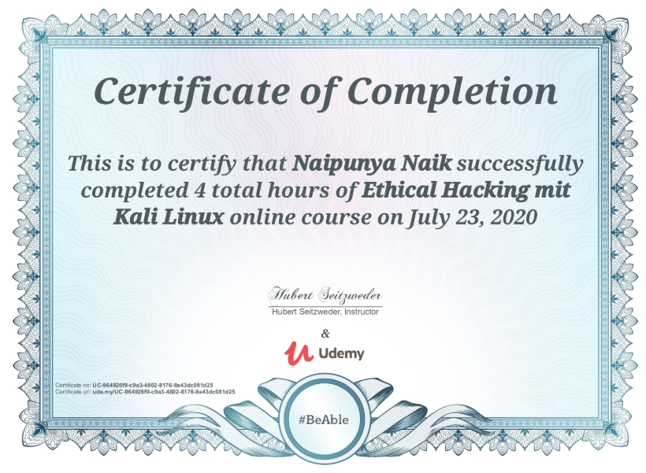

Coding Challenges Details: (Attach the snapshot and briefly write the report for the same).

PROBLEM STATEMENT:- **Task**  
Given the *meal price* (base cost of a meal), *tip percent* (the percentage of the *meal price* being added as tip), and *tax percent* (the percentage of the *meal price* being added as tax) for a meal, find and print the meal's *total cost*.

**Note:** Be sure to use precise values for your calculations, or you may end up with an incorrectly rounded result!

**Input Format**

There are  lines of numeric input:  
The first line has a double,  (the cost of the meal before tax and tip).  
The second line has an integer,  (the percentage of  being added as tip).  
The third line has an integer,  (the percentage of  being added as tax).

**Output Format**

Print the total meal cost, where  is the rounded integer result of the entire bill ( with added tax and tip).

**Sample Input**

12.00

20

8

**Sample Output**

15

I ATTEMPTED THIS QUESTION AND PASSED TWO TEST CASES AND UPLOADED THE CODE IN GITHUB REPOSITORY.

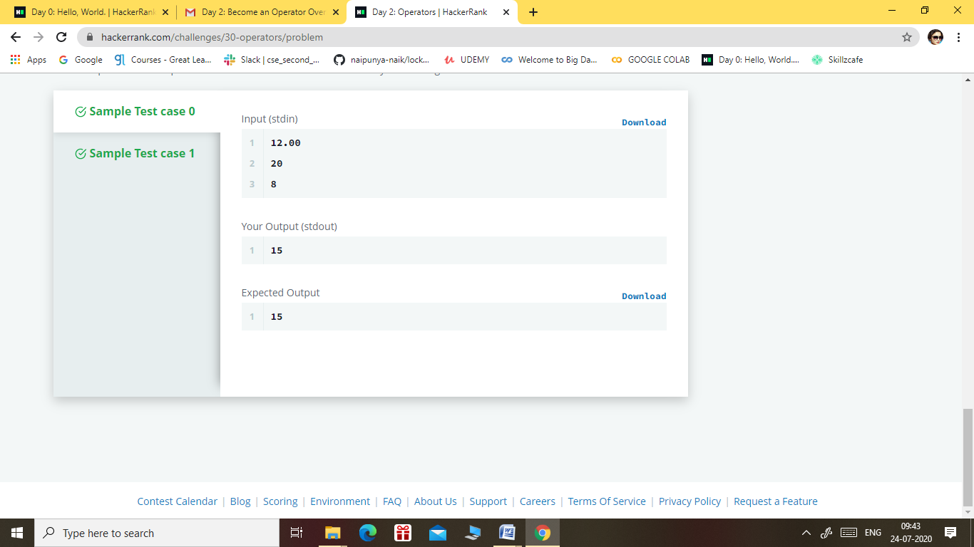

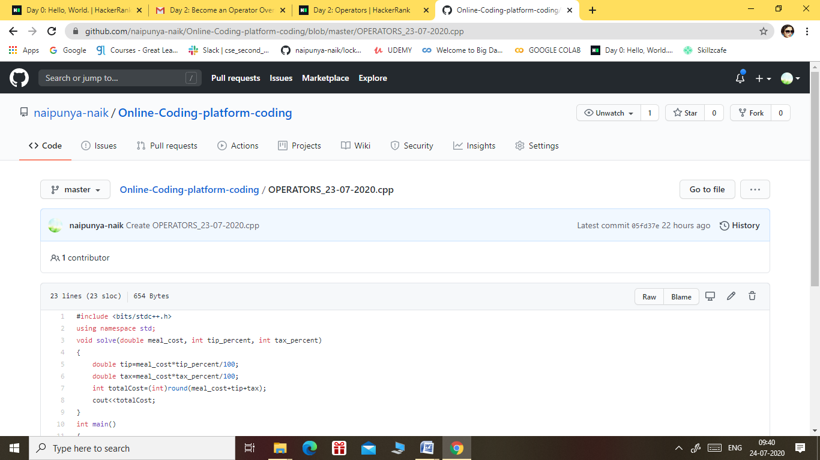

GITHUB REPOSITORY LINK:-

<https://github.com/naipunya-naik/Online-Coding-platform-coding/blob/master/OPERATORS_23-07-2020.cpp>